Alternate Interior Angles
# Source: AI Source: Provided by: [Data Path: Persons Table -> ID Column: 1, Name_En Column: Motasem Essam] -> From: [ChatGPT] on [7/25/2026]
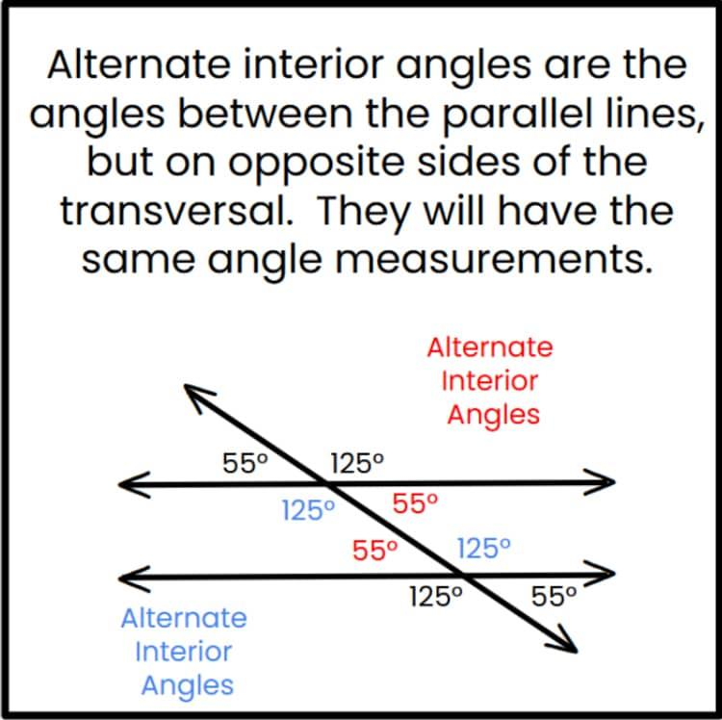
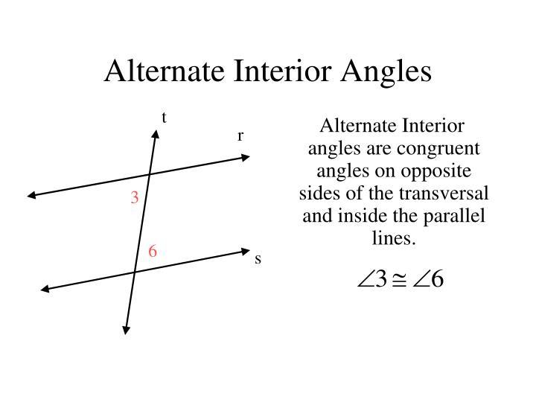
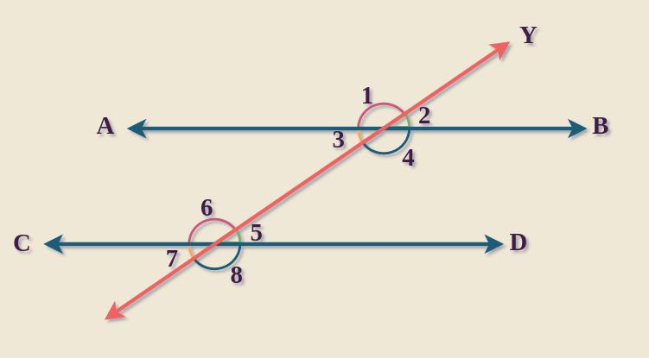
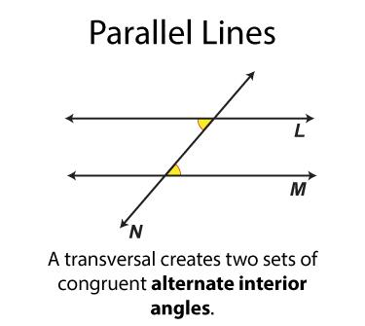
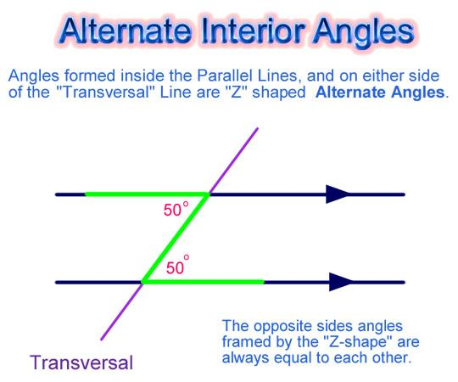
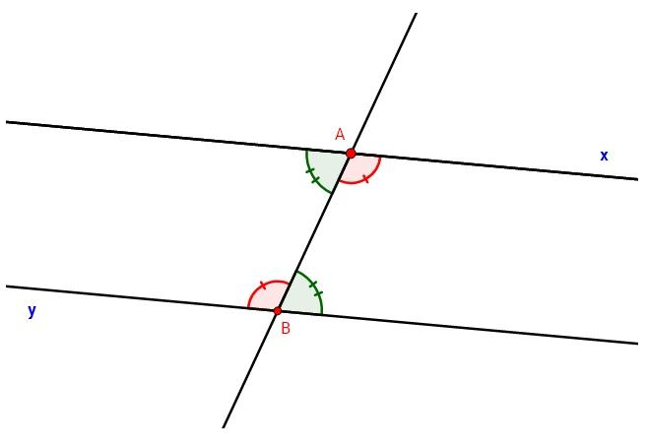

Definition
# Source: AI Source: Provided by: [Data Path: Persons Table -> ID Column: 1, Name_En Column: Motasem Essam] -> From: [ChatGPT] on [7/25/2026]
Alternate Interior Angles are a pair of angles that lie between two lines and on opposite sides of a transversal.
When the two lines are parallel, alternate interior angles are equal in measure (congruent).

Characteristics
# Source: AI Source: Provided by: [Data Path: Persons Table -> ID Column: 1, Name_En Column: Motasem Essam] -> From: [ChatGPT] on [7/25/2026]
Alternate interior angles:
- Are formed when a transversal intersects two lines.
- Lie between the two lines (interior region).
- Are on opposite sides of the transversal.
- Are located at different intersections.
- Are congruent only if the two lines are parallel.

Illustration
# Source: AI Source: Provided by: [Data Path: Persons Table -> ID Column: 1, Name_En Column: Motasem Essam] -> From: [ChatGPT] on [7/25/2026]
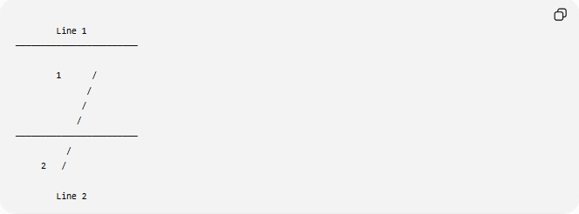

Line 1
────────────────────────

1 /
/
/
/
────────────────────────
/
2 /

Line 2
Angles 1 and 2 lie:
- Between the two lines.
- On opposite sides of the transversal.
Therefore, they are alternate interior angles.

Alternate Interior Angles Theorem

Theorem
# Source: AI Source: Provided by: [Data Path: Persons Table -> ID Column: 1, Name_En Column: Motasem Essam] -> From: [ChatGPT] on [7/25/2026]
If two parallel lines are cut by a transversal, then each pair of alternate interior angles is congruent.
If:
$$l_{1}∥l_{2}$$
then:
$$∠1≅∠2$$
or
$$m∠1=m∠2$$

Converse Theorem
# Source: AI Source: Provided by: [Data Path: Persons Table -> ID Column: 1, Name_En Column: Motasem Essam] -> From: [ChatGPT] on [7/25/2026]
If two lines are cut by a transversal and a pair of alternate interior angles are congruent,
$$m∠1=m∠2$$
then the two lines are parallel.

Mathematical Representation
# Source: AI Source: Provided by: [Data Path: Persons Table -> ID Column: 1, Name_En Column: Motasem Essam] -> From: [ChatGPT] on [7/25/2026]
For parallel lines:
$$m∠A=m∠B$$
or
$$θ_{1}=θ_{2}$$

Example 1
# Source: AI Source: Provided by: [Data Path: Persons Table -> ID Column: 1, Name_En Column: Motasem Essam] -> From: [ChatGPT] on [7/25/2026]
Given:
$$m∠1={55}^{∘}$$
Find:
$$m∠2$$
Since they are alternate interior angles:
$$m∠2={55}^{∘}$$

Example 2
# Source: AI Source: Provided by: [Data Path: Persons Table -> ID Column: 1, Name_En Column: Motasem Essam] -> From: [ChatGPT] on [7/25/2026]
Given:
$$m∠A={\left(3x+10\right)}^{∘}$$
$$m∠B={\left(5x-30\right)}^{∘}$$
Since alternate interior angles are equal:
$$3x+10=5x-30$$
Solve:
$$40=2x$$
$$x=20$$
Angle measure:
$$3\left(20\right)+10={70}^{∘}$$
Therefore:
$$m∠A=m∠B={70}^{∘}$$

Position of Alternate Interior Angles
# Source: AI Source: Provided by: [Data Path: Persons Table -> ID Column: 1, Name_En Column: Motasem Essam] -> From: [ChatGPT] on [7/25/2026]
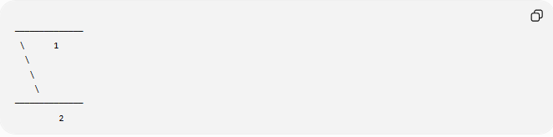
──────────────
\ 1
\
\
\
──────────────
2
The two angles:
- Lie inside the parallel lines.
- Are on opposite sides of the transversal.

Relationship with Other Angles
# Source: AI Source: Provided by: [Data Path: Persons Table -> ID Column: 1, Name_En Column: Motasem Essam] -> From: [ChatGPT] on [7/25/2026]
When two parallel lines are cut by a transversal:
- Corresponding angles are equal.
- Alternate interior angles are equal.
- Alternate exterior angles are equal.
- Same-side interior angles are supplementary.

Real-World Examples
# Source: AI Source: Provided by: [Data Path: Persons Table -> ID Column: 1, Name_En Column: Motasem Essam] -> From: [ChatGPT] on [7/25/2026]
Alternate interior angles appear in:
- Railroad tracks crossed by a road.
- Bridge structures.
- Parallel fences with a crossing path.
- Building frameworks.
- Engineering blueprints.
- Architectural drawings.

Applications
# Source: AI Source: Provided by: [Data Path: Persons Table -> ID Column: 1, Name_En Column: Motasem Essam] -> From: [ChatGPT] on [7/25/2026]
Alternate interior angles are used in:
- Plane Geometry
- Coordinate Geometry
- Parallel Line Geometry
- Trigonometry
- Engineering
- Architecture
- Construction
- Surveying
- CAD (Computer-Aided Design)
- Technical Drawing

Advantages
# Source: AI Source: Provided by: [Data Path: Persons Table -> ID Column: 1, Name_En Column: Motasem Essam] -> From: [ChatGPT] on [7/25/2026]
Studying alternate interior angles helps to:
- Find unknown angle measures.
- Prove lines are parallel.
- Solve geometry proofs.
- Understand transversal relationships.
- Analyze parallel structures.

Limitations
# Source: AI Source: Provided by: [Data Path: Persons Table -> ID Column: 1, Name_En Column: Motasem Essam] -> From: [ChatGPT] on [7/25/2026]
Alternate interior angles are equal only when:
- Two lines are parallel.
- A transversal intersects both lines.
If the lines are not parallel, alternate interior angles are not necessarily equal.

Comparison with Other Angle Relationships
# Source: AI Source: Provided by: [Data Path: Persons Table -> ID Column: 1, Name_En Column: Motasem Essam] -> From: [ChatGPT] on [7/25/2026]
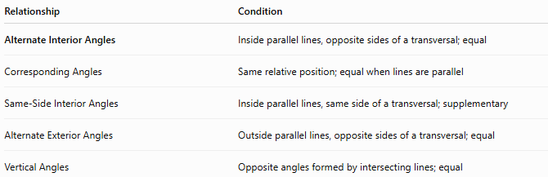
Relationship | Condition
Alternate Interior Angles | Inside parallel lines, opposite sides of a transversal; equal
Corresponding Angles | Same relative position; equal when lines are parallel
Same-Side Interior Angles | Inside parallel lines, same side of a transversal; supplementary
Alternate Exterior Angles | Outside parallel lines, opposite sides of a transversal; equal
Vertical Angles | Opposite angles formed by intersecting lines; equal

Key Points
# Source: AI Source: Provided by: [Data Path: Persons Table -> ID Column: 1, Name_En Column: Motasem Essam] -> From: [ChatGPT] on [7/25/2026]
- Alternate Interior Angles lie:
  - Between two lines.
  - On opposite sides of a transversal.
- If the lines are parallel:
$$m∠1=m∠2$$
- Their converse theorem can be used to prove that two lines are parallel.

Conclusion
# Source: AI Source: Provided by: [Data Path: Persons Table -> ID Column: 1, Name_En Column: Motasem Essam] -> From: [ChatGPT] on [7/25/2026]
Alternate Interior Angles are pairs of angles located between two lines and on opposite sides of a transversal. When the lines are parallel, these angles are always congruent (equal in measure). This relationship is one of the most important theorems in geometry and is widely used in plane geometry, coordinate geometry, trigonometry, engineering, architecture, construction, surveying, CAD, technical drawing, and computer graphics to determine unknown angles and establish parallel-line relationships.

